FOR IMMEDIATE RELEASE

LG OFFERS ‘CLEAN REMOTE’ WITH NEW HOTEL TVs

Part of LG Health Protocol Initiative, New TV Remote
Helps Hoteliers Give Returning Guests More Peace of Mind

LINCOLNSHIRE, Ill., June 22, 2020 – Addressing health concerns and confidence of American travelers, LG Business Solutions USA is offering hotel operators a free “Clean Remote” with every new LG hotel TV. The special remote control is designed to be safer thanks to a non-porous, sealed membrane surface that can reduce bacteria and germs by as much as 99 percent compared to traditional remotes,, according to Clean Remote LLC.
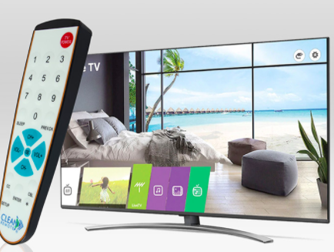
“The Clean Remote solution pairs perfectly with LG hotel TVs to provide guests a safer in-room experience and some peace of mind,” said Mike Kosla, Vice President of Hospitality, LG Business Solutions USA. “TV remotes are the most touched object in a hotel room, making them a hotbed for germs and bacteria, so this is an attractive solution for hoteliers, especially now.”

While the CDC recommends that hotels clean and disinfect remote controls daily, standard remotes have gaps and crevices around the buttons that can harbor dirt and germs, said Clean Remote LLC President Michael Monsky. “Because of this, they are nearly impossible to clean properly and may be damaged by liquid cleaner, The Clean Remote’s unique membrane surface is made to be easily cleaned and sanitized,” he said.

The Clean Remote connects seamlessly with all LG Hotel TV models, with no additional setup required. Each remote is specifically designed with staff and guests in mind with a simple layout and large, high visibility keys. Its spill-proof design prevents liquid damage, while its “not for home use” designation discourages theft and its hidden battery cover prevents battery loss.
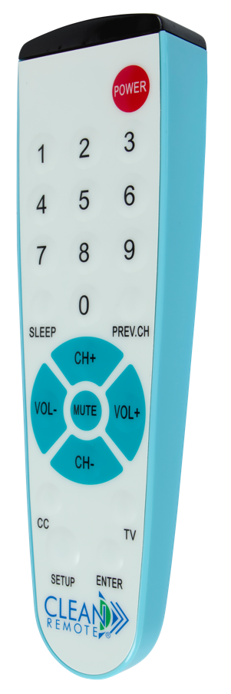
“LG is the leading provider of hotel TVs in the U.S., known for providing exceptional hospitality experiences. Offering the Clean Remote to hotel TV customers builds on this promise with the added elements of safety and cleanliness,” Monsky said. “The reality is that many guests eat and drink with the TV remotes in their hands or fall asleep with them in the bed. With cleanliness being the utmost concern especially now, it’s important for hotels to offer remote solutions that minimize risk – and the Clean Remote does just that.”

Offering the Clean Remote is part of LG Business Solutions USA’s new Health Protocol initiative – a suite of products and packages designed to provide commercial businesses with tools to help keep employees and guests safe. “Safety is our primary concern, and LG is investing significantly in supporting our customers’ business needs during the pandemic,” Kosla concluded.

For more information about this limited time promotion and for and a complete list of compatible models, www.CleanRemote.com/LG. For hi-res images, click here.

###

About LG Business Solutions USA
The LG Electronics USA Business Solutions division serves commercial display customers in the U.S. lodging and hospitality, digital signage, systems integration, healthcare, education, government and industrial markets. Based in Lincolnshire, Ill., with its dedicated engineering and customer support team, LG Electronics USA Business Solutions delivers business-to-business technology solutions tailored to the particular needs of business environments. LG Electronics USA Inc., based in Englewood Cliffs, N.J., is the North American subsidiary of LG Electronics Inc., a $53 billion global force in consumer electronics, mobile communications, home appliances and air solutions. LG is a 2020 ENERGY STAR® Partner of the Year-Sustained Excellence. For more information, please visit www.LGSolutions.com.

About Clean Remote LLC
Based in Tampa, Fla, since 2001, Clean Remote LLC manufactures the No. 1 selling replacement TV remote for the hospitality and healthcare industry. Clean Remotes automatically synch with almost all TV brands. The remotes also control most cable TV set-top boxes as well as hotel and healthcare TV systems. Clean Remotes are designed to be the “Safer Solution;” they can be easily sanitized to help reduce the threat of germs and bacteria. Clean Remotes are distributed globally by leading hospitality and healthcare distributors and can be found in more than 500,000 guest and patients’ rooms. For more information, please visit www.cleanremote.com

Media Contacts:

LG Electronics USA

Kim Regillio
847 941 8184
kim.regillio@lge.com

Jess Passananti
212 481 3456 x23
jess@griffin360.com

